

February 15, 2019

Ryan Orn
Capital Rivers Commercial
2901 K Street, Suite 210
Sacramento, CA 95816

Re: Counter Proposal for a build to suit lease with
THE LEARNING EXPERIENCE 17001 Golben Valley Prkwy, lathrop ca

Dear Ryan:

An entity to be formed by The Learning Experience®, (the “Tenant”), proposes to lease a free-standing, build-to-suit child care center at the above referenced location, subject to the following terms and conditions:

1. LANDLORD: Ramona Chace, LLC a California limited liability company

2. PREMISES: 9,990 square foot building (one floor building) (the “Building”) and fenced exterior playground area located immediately adjacent to the Building and having of approximately 13,000SF.

Type of location (check one):
____ Freestanding building, no other uses
____ Outparcel in shopping center/development
____ Inline in shopping center/multi-story building/office building
XX Other (_ END CAP )

3. PROPERTY: That certain real property located in the City of Lathrop, County of San Joaquin and State of California, as shown on the site plan, concept plan or survey attached as an exhibit hereto. If the Premises is an outparcel or inline, the attached site plan must clearly identify the location of the proposed premises within the development/building.

4. USE: Tenant may use the Premises for a child care center and related educational, enrichment and child businesses and activities, including, without limitation, hot meal, snack service and birthday parties, and for any other lawful purpose.

5. COMMENCEMENT DATE: The date that Landlord delivers the Premises to Tenant with all of the Delivery Conditions (defined below) having been satisfied.

6. RENT COMMENCEMENT: The date that is sixty (60) days following the Commencement Date, provided however that the Rent Commencement Date shall not occur unless and until Landlord has completed all punch list items, any environmental remediation, and any other Landlord obligations that may be necessary in order for Tenant to obtain its childcare license and commence operating in the Premises.

7. TERM: Initial lease term of fifteen (15) years, plus two (2) options of five (5) year each.

8. BASE RENT: Base Rent shall be paid monthly as follows:

(i) During the Initial Term, Base Rent of $33.60 SF/annum (NNN) of the Leased Premises, with increases of 10 % in years 6 and 11, and in the first year of each option term, provided, however;

(ii) Notwithstanding Section 8(i) above, Tenant shall receive a rent concession during the first twelve (12) months following the Rent Commencement Date, during which time Tenant shall pay as monthly Base Rent the greater of: (a) 16% of Tenant’s gross collected revenue, or (b) an abatement of Base Rent, to be amortized as provided below:

Month 1 – 6 0.00 % of Base Rent
Month 7 – 12 70.00 % of Base Rent

9. ADDITIONAL RENT (NNN): From and after the Rent Commencement Date, Tenant shall be responsible for all real estate taxes during the Term. If the Leased Premises is part of a larger shopping center, office park, multi-story building, or similar development, then Tenant shall pay, as additional rent, tenant’s share of the reasonable and typical costs and expenses paid by Landlord for the operation of the common areas of the Property (the “CAM”), to be specifically defined in the Lease. In no event may the CAM payable by Tenant for any calendar year exceed the previous year's actual CAM by more than five percent (5%), on a non-cumulative basis for controllable expenses. If Tenant will be responsible for CAM, Landlord shall attach hereto the most recent annual detailed budget of CAM and real estate taxes for the development/building, unless the development/building consists of entirely new construction, in which case Landlord estimates the budget for CAM and real estate taxes in the first Lease Year to be approximately $---SF.

10. LANDLORD’S WORK: Landlord shall construct a turnkey child care center substantially similar to the child care center in Tenant’s Prototypical Plans and Specifications (the “Tenant’s Plans”), which plans Tenant shall supply to Landlord prior to entering into the Lease. Tenant’s Plans include without limitation, prototype plans for the Playground and the Playground equipment. Landlord acknowledges and agrees that in various sections of Tenant’s Plans there are certain required/preferred vendors that Landlord must use as specified therein. The Tenant’s Plans are for general reference and guidance only, and the construction of the Premises by Landlord (including all Site Work) shall be performed in accordance with plans and specifications to be prepared by an architect designated by Tenant (at Landlord’s sole cost and expense) (the “Architect”), and approved by Tenant following the execution of the Lease (the “Final Plans”). Construction shall be completed by Landlord’s designated General Contractor, subject to Tenant’s approval. Further, Landlord shall pay Tenant an FF&E allowance of $8.50 per square foot, which allowance shall be paid in full within ninety (90) days of the issuance of a building permit. Landlord shall warrant the roof for the Term of the Lease or provide tenant a valid and enforceable manufacturer’s warranty equal to the term of the lease (financial stability of the manufacturer must be approved by Tenant), and shall supply new heating, venting and air conditioning units having at least a five (5) year warranty.

11. ARCHITECT/DESIGN: Landlord, at its sole cost, will engage the Architect to create all architectural/engineering plans pursuant to Tenant's Plans and all site-specific specifications. Further, Landlord will pay Tenant’s designee (“TLE Design”) a Construction Supervision fee of $2.00 per square foot for the following:

(i) TLE Design’s assistance with preparation of a basic floor plan of the Building (the “Floor Plan”), which will be used by the Architect for the drafting of the Final Plans,

(ii) Assistance to the Architect with the design of the Building,

(iii) TLE Design’s review of the plans for the Site Work and the Final Plans, and

(iv) two progress visits by TLE Design during the course of the construction, the earliest such visit being at the time of rough mechanicals.

12. DELIVERY CONDITIONS. The “Delivery Conditions” shall be deemed satisfied upon the occurrence of all of the following:

(a) Landlord has delivered actual and exclusive possession of the Premises to Tenant in clean condition, free and clear of all violations, with the Landlord’s Work substantially complete; and unconditional and permanent Certificate of Occupancy for the Premises expressly allowing the Permitted Use (the “CO”), or a temporary CO allowing Tenant to open for business without conditions, has been delivered to Tenant;

(b) Landlord has provided Tenant with at least thirty (30) days advance written notice of the anticipated Commencement Date and Tenant has been permitted early entry to the Leased Premises (in accordance with terms to be further specified in the Lease); and

(c) Landlord has provided a recent Phase I report, has remediated any hazardous substances, and has performed such testing as may be required by law.

13. SIGNAGE: Subject to local ordinances, Landlord, at its cost, shall erect/place the following signs for Tenant’s sole use: (a) a building façade sign, (b) Tenant’s trademarked ABCD/1234 blocks, (c) a monument/pylon sign at the front drive way entrance to the Premises; and (d) a temporary “Coming Soon” sign. All such signage shall be constructed in accordance with Tenant’s signage specifications. Landlord shall be responsible for ensuring all such signage complies with all applicable laws.

14. PARKING: Landlord shall provide Tenant, its employees, agents, customers, invitees and visitors, with the exclusive use of the following parking spaces: the greater of (4) spaces per 1,000 square feet of the premises, or such number as required by applicable law, with at least fifteen (15) of such parking spaces being located directly in front of the Building and clearly identified for parent dropoff/pickup.

15. REAL ESTATE COMMISSION: Landlord and Tenant warrant to one another that they have not dealt with any Brokers other than Alan Stahl of Future In-Site Realty Associates, Inc. and Capital Rivers Commercial Inc in connection with this transaction, and therefore are to be recognized as the procuring cause of this transaction. Landlord will be solely responsible to pay a commission pursuant to the listing agreement , calculated based on the value of the rent over the 15 year lease term payable. The commission shall be payable as follows: 50% upon execution the lease and the balance upon tenant taking occupancy of the premises, and executing a Rent Commencement form. This commission is to be shared equally by the two brokers.

Commission per Listing Agreement
6% of the total base rental for the first 60 months in which rent is to be paid, plus
3% of the total base rental for months 61-120
1.5% of the total base rental for the remainder of the term to a maximum of 20 years

16. ASSIGNMENT AND SUBLETTING: Landlord understands and acknowledges that Tenant’s affiliates are in the business of franchising childcare centers to qualified franchisees (each, a “Franchisee”) and that Tenant will be a newly formed entity whose only asset will be its rights under the Lease, and that Tenant has been formed solely to enter into the Lease. As a material inducement to Tenant to enter into the Lease, Tenant may, at its sole option, assign the Lease or sublease the Premises to a Franchisee duly qualified pursuant to Tenant's qualification procedures then in effect.

17. PRE-LEASE CONTINGENCIES: This letter of intent is subject to and contingent upon the following:

(i) No restrictions by Landlord or governmental agencies that limit the childcare licensed capacity of the center less than the maximum permitted capacity under state laws and regulations.

(ii) Landlord’s acceptance of Tenant’s standard form of Lease.

(iii) Landlord and Broker’s non-disclosure of Tenant’s Prototype Plans and Specifications, the terms of this LOI, and Tenant’s name and information, all such information to be kept confidential.

(iv) Tenant completing a site specific Demographic Real Estate Analysis, for a 1, 3, and 5 miles radius based on 2018 demographics.

(v) Unless and until a written Lease is formally signed by the parties, Landlord shall not make or file an application for any governmental approvals for the property relating to Tenant’s proposed use.

(vi) Landlord represents and warrants that, to its actual knowledge, the Property is not contaminated with, or threatened with contamination by, any hazardous substances in quantities that violate applicable laws, or any other environmental conditions, that might interfere with the use of the Premises as contemplated by Tenant. Further, Landlord represents and warrants that there are no unusual on- or off-site conditions, such as neighboring gas stations, high tension wires, flood hazard areas, electrical substations, or mines, except as follows: ____________________________________ (if left blank, then no such conditions exist); and

(vii) Landlord is the fee owner of the Property o, and represents and warrants that there are no declarations, reciprocal easement agreements, condominium documents or similar types of documents recorded or to be recorded against the Property which might impact the use of the Property by Tenant, except as follows: ____________________________ (if left blank, then no such restrictions exist),

24. GUARANTY: The Parent company of Tenant shall offer a limited guaranty in accordance with the attached form.

This letter of intent is being provided with the understanding that it and the information contained herein is confidential and will be held by the Landlord and any broker in confidence, and will not be disclosed to any person or third parties other than employees, legal counsel and/or accountants to the extent such persons need to know the same. Notwithstanding the following paragraph, the confidentiality provisions set forth herein shall be binding on Landlord regardless of whether a lease agreement is ultimately entered into.

Landlord and Tenant acknowledge that this proposal is not a lease, and that it is intended as the basis for the preparation of the Lease (which Lease shall be prepared on Tenant’s standard form of lease). The Lease shall be subject to Landlord and Tenant’s approval, and only a fully executed lease shall constitute a binding lease for the Premises (such fully-executed lease is referred to herein as the “Lease”). Except as otherwise set forth herein, this letter of intent shall not be binding upon either party until the Lease is entered into. Please note that this letter of intent is valid until February 15, 2019, unless countersigned and faxed or emailed to Tenant at 805-522-0094 or josh.a.stahl@gmail.com and alanstahl101@gmail.com, after which time it may be withdrawn by the Tenant. Thank you.

Sincerely,  ________________________________ | Acknowledged and agreed to by Landlord:  Ramona Chace, LLC  A California limited liability company  By: 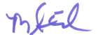__  Michael A Clevenger  Title: _Member____________  Date: February 15, 2019
Attachments:
Form of guaranty
Survey/Site Plan/Concept Plan
CAM & RE Tax Budget (if applicable)

EXHIBIT E
GUARANTY OF RENT

FOR VALUE RECEIVED, the undersigned (“Guarantor”) hereby guarantees to Landlord, its successors and assigns, the timely payment of all monetary obligations of Rent as and when due pursuant to a Lease (“Lease”) dated of even date herewith between _______________________, a ________ __________________ (“Landlord”) and TLE at _______________, LLC, a __________ limited liability company (“Tenant”) for which this Guaranty is annexed as Exhibit “E” to the Lease as specified. All terms not defined herein shall have the meanings ascribed thereto in the Lease.

Notwithstanding the foregoing and anything in the Lease to the contrary, this Guaranty of Rent shall be limited to a maximum liability amount of Five Hundred Thousand Dollars ($500,000.00) in the aggregate and this maximum amount shall be reduced by One Hundred Thousand Dollars ($100,000.00) on each anniversary of the Effective Date, and shall further be reduced by the amount of any payment made to Landlord on Tenant’s behalf, until such time as said amount has been reduced to Zero ($0.00), at which time this Guaranty of Rent shall become null, void, and of no further force or effect.

This Guaranty shall be limited to payment of past due arrearages, including late fees and interest as provided for under the Lease, and other damages arising from a monetary Event of Default occurring under the Lease and any reasonable attorney fees, costs and expenses for collection. Upon an Event of Default, Landlord shall offset any portion of the remaining Guaranty against any payments received by Landlord from a new tenant at the Leased Premises, less any actual costs that Landlord expends due to the Event of Default.

Guarantor shall have no obligation to make any payments to Landlord on Tenant’s behalf under this Guaranty unless and until Landlord first exhausts all legal remedies against Tenant, including without limitation, the commencement of eviction proceedings. This Guaranty of Rent shall automatically become null and void and of no effect if any act or omission of Landlord increases Guarantor’s risk hereunder including, but not limited to, any modification of the Lease, the occurrence of any custom or practice at variance with the terms of the Lease or default by Landlord thereunder.

IN WITNESS WHEREOF, this Guaranty of Rent has been duly executed by the undersigned as of the ___ day of _____________, 20__.

Witness: ______________________ GUARANTOR:

THE LEARNING EXPERIENCE HOLDING CORP., a Delaware Corporation

____________________________ By: __________________________
Name Title

EXHIBIT “A”

That real property, together with improvements thereon, commonly known 18007 Golden Valley Prkwy. Lathrop , CA

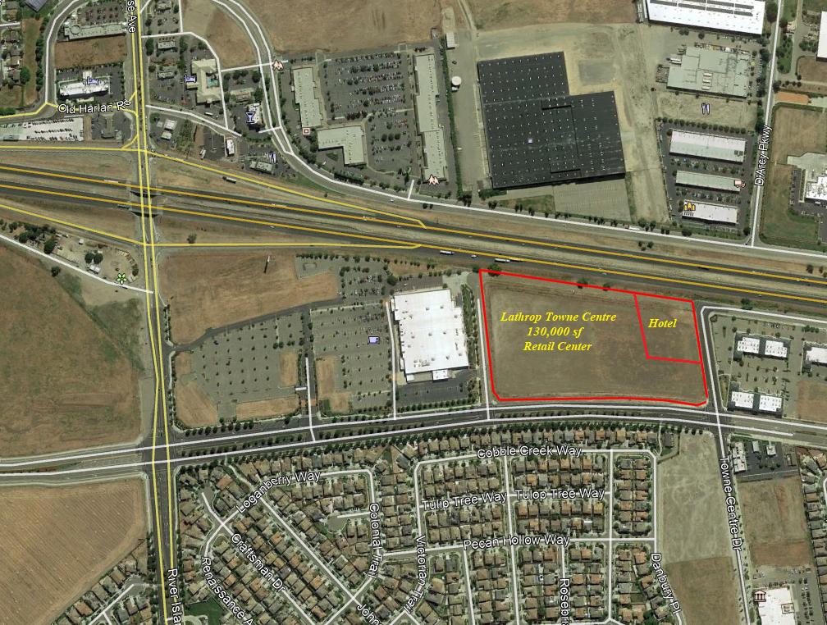

EXHIBIT “B”
Site Plan & floor plan

